*images of design concepts are below

| **DC #** | **Pros** | **Cons** |
| --- | --- | --- |
| 1 |  |  |
|  |  |
|  |  |
|  |  |
| 2 |  |  |
|  |  |
|  |  |
|  |  |
| 3 |  |  |
|  |  |
|  |  |
|  |  |
| 4 |  |  |
|  |  |
|  |  |
|  |  |
| 5 |  |  |
|  |  |
|  |  |
|  |  |
| 6 |  |  |
|  |  |
|  |  |
|  |  |

| **DC #** | Design |
| --- | --- |
| 1 |  |
| 2 |  |
| 3 |  |
| 4 |  |
| 5 |  |
| 6 |  |

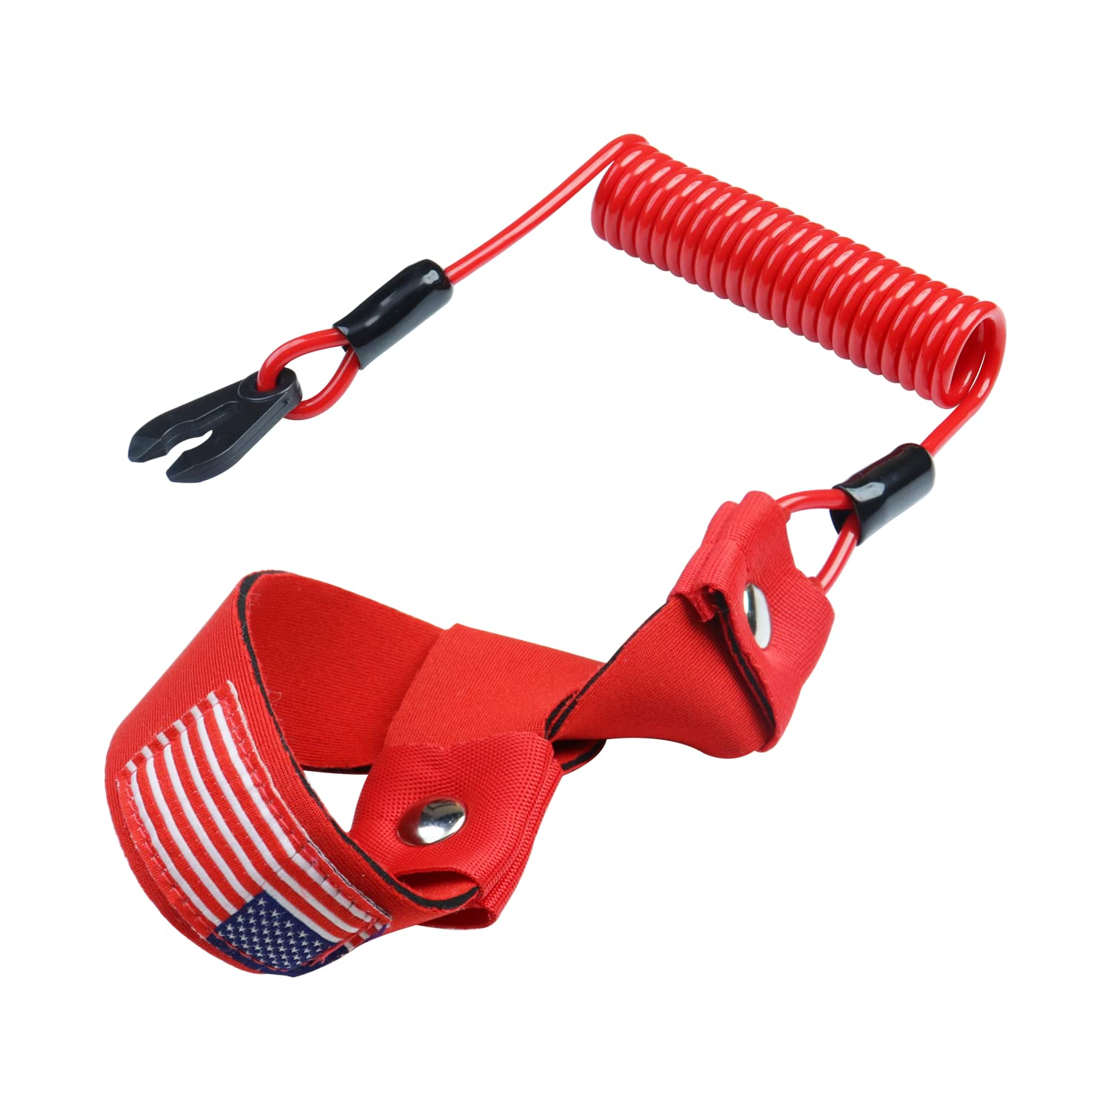

Possible design:

* Pen mechanism 5th wheel [Push-push button for click pen 1](https://www.youtube.com/watch?v=Vg--uMe9GLg)
  + 2 front wheels are swivel, two back wheels are fixed
* 